Lab 8

Routing and Insomnia

Start node.js.
Use VSCode as your editor.

Basic Routing

In Lab 7, we have seen a basic application which serves HTTP request for the homepage.

Routing refers to determining how an application responds to a client request to a particular endpoint, which is a URI (or path) and a specific HTTP request method (GET, POST, and so on).

We will extend our Hello World program to handle more types of HTTP requests.

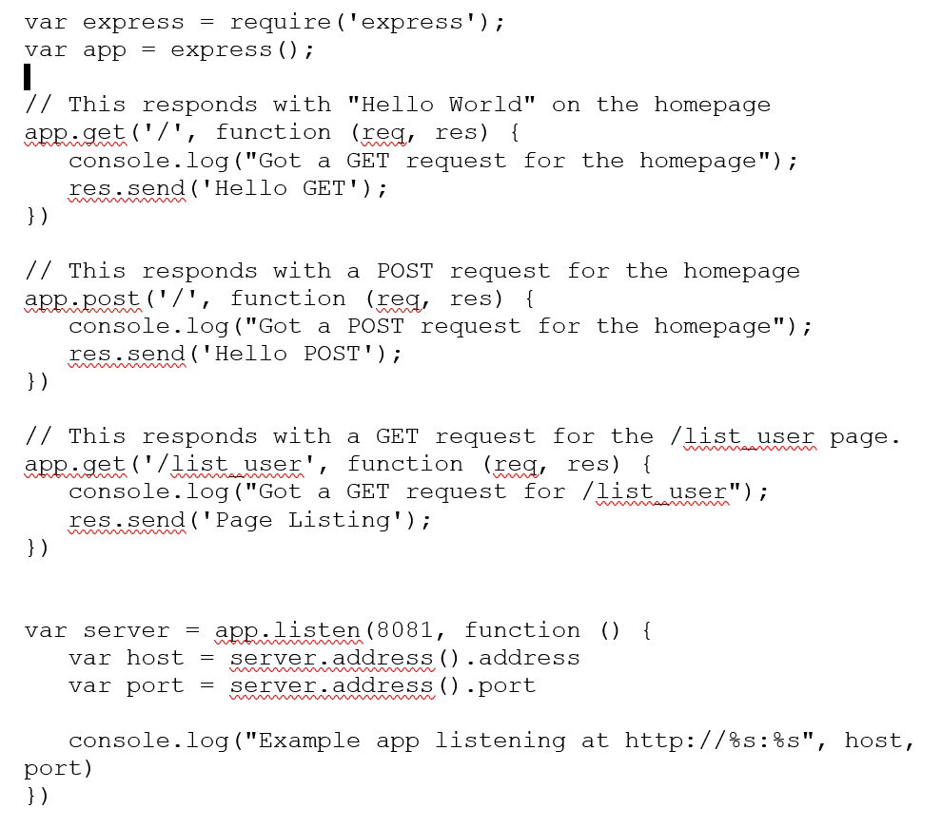

Save the above code in a file named server.js

Insomnia

Now install Insomnia from https://insomnia.rest/
Insomnia is an Open Source API Client.
It provides a very simple front end.
It is very useful way of testing a back end.

Free Weather API

Open-Meteo gives free weather forecast APIs for open-source developers and non-commercial use. No API key is required.

https://open-meteo.com/en

Questions

- Run the server. What command did you use?

- How do you know if the server is running correctly?

- Test the GET request method. How did you test the GET method?

- Test the POST request method. How did you test the POST method?

- Test the GET request for the /list_user page. How did you do this?

- Add a variable called count to your server and initialise it to 0. Have it increment every time a GET request is made. Display the value of count on the web page and also in the console.

- Repeat questions 3, 4 and 5 using Insomnia. How did you do the testing with Insomnia?

- Explain how you got the data for the weather for Berlin using Insomnia and Open Meteo.

- Explain how you got the data for the weather for Dublin using Insomnia and Open Meteo.

References
Node.js - Express Framework. (n.d.). Retrieved March 21, 2022, from https://www.tutorialspoint.com/nodejs/nodejs_express_framework.htm
Node.js web application framework. Express. (n.d.). Retrieved March 21, 2022, from https://expressjs.com/

